Art I: Zentangle® Drawings
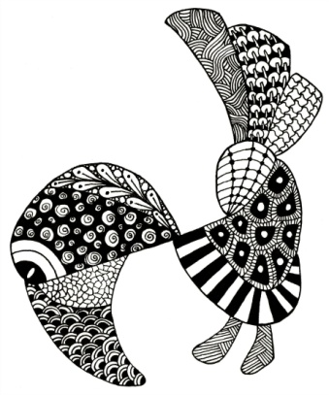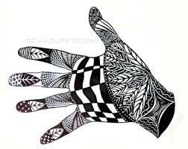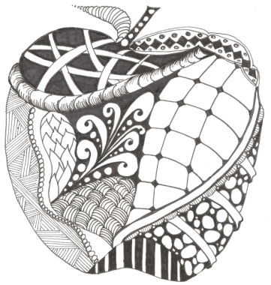
What is a Zentangle?
Zentangle - A Zentangle is an abstract drawing created by using repetitive patterns. It is usually structured within a certain shape. Drawing a Zentangle is entertaining, relaxing, and a great way to express yourself creatively.
String - A string is generally a random line drawn in pencil which creates an area within which you draw your tangles.
Tangle - In its verb form “tangle” means to draw a tangle. You tangle a tangle, and in that process create Zentangle art. In its noun form this word is used as a replacement for “pattern.”

For more information about the Zentangle process, go to www.Zentangle.com
Instructions:
- Complete your design matrix with patterns you could use for your Zentangle.
- Brainstorm different shapes you could use as the outline or frame of your Zentangle. You will want to choose something recognizable, like the images at the top of this rubric.
- When you have decided on a frame, draw it out on your paper using pencil.
- Draw in some “strings” to fit your “tangles” into. These lines can be random, or they can help make your frame into a recognizable object, like the eyes and feathers of the bird above.
- Choose at least 5 patterns from your design matrix to use in your Zentangle.
- Fill in your Zentangle with your tangles (patterns). You should use at least 8 tangles in your completed image. At least 5 must come from your design matrix.
- When your Zentangle is complete, go over everything with black marker and/or black pen ink.
- On your black sheet of paper, outline your object or hand with a pencil lightly, then cut out that shape neatly. Use this sheet as a tracing paper to show you where to cut your white sheet of paper with Zentangles.
- Glue the Zentangle object from white sheet onto black paper and conversely with the black paper on the Zentangle white sheet.
- Complete the rubric and paperclip it to your finished work. Hand everything in.

Project Requirements:
- Students will create a Zentangle drawing using patterns created on their Elements and Principles design matrix.
- Students will demonstrate their knowledge of the elements and principles through the creation of tangles or patterns.
- Students will use at least eight different patterns in their drawing, and at least five must come from their design matrix.
Zentangle Drawing Rubric | Student Evaluation | Teacher Evaluation
Creativity  - Drawing includes at least 8 patterns/designs  - Zentangle is created within a recognizable outline  - Patterns are creative, varied, and unique | Needs Strong  Work  1 __ 2 __ 3 __ 4 __ 5 | Creativity:  /50
Level of Effort/Attitude  - Worked hard every class  - Exhibited a positive attitude  - Work is complete | Needs Strong  Work  1 __ 2 __ 3 __ 4 __ 5 | Effort/Attitude:  /25
Craftsmanship  - Evidence of hard work and quality of skill is apparent  - Zentangle is neatly crafted  - Lines are well drawn and even  - Paper is cut and glued neatly | Needs Strong  Work  1 __ 2 __ 3 __ 4 __ 5 | Craftsmanship:  /25
Final Teacher Evaluation:

/100 points

