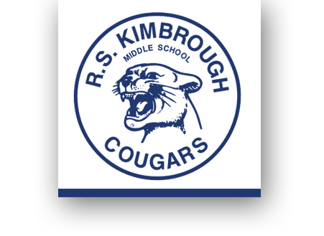
August 24, 2015

Dear Families,

Welcome to Kimbrough’s Art Program! I am thrilled to share my love of art and creativity with your child as we begin a full year of exciting activities that will help build their creativity and confidence.

This year in art, your student will be doing all sorts of amazing things. We will learn about the Elements and Principles of Art, color theory, techniques (for drawing, painting, building…you name it!), and the many careers and applications for creativity in the world. All the while, I’ll be pulling in math, language arts, and social studies connections for some sneaky cross-curricular learning. It is my goal that my students will leave my class at the end of the year with a strong mindset for creative problem-solving, which is a highly sought after skill in today’s world.

I have sent this pack of papers has been sent home outlining the course description, art contract, and parent/guardian information sheet. Please read through these and place your signature on all three as these will be the first three grades of the year. (You may keep this page.)
***Perhaps the most important sheet to fill out is the Parent/Guardian Information Sheet. I would like to have all ways to communicate to you that your student is excelling in my class, had a good behavior day, or is having trouble following the rules of the classroom. I will also contact you if your student’s artwork has been selected to enter into a contest or district art show.

This course counts as a High School Art 1 credit should students pass their portfolio test (see Portfolio Rubric attached). Your Advanced Art student is strongly encouraged to participate in the Junior Visual Arts Scholastic Event that will take place on April 16th. Students may create any one original artwork they would like to submit, but it must not come from any outside source. As we complete these works, students will be writing about their artistic process (attached). We will also be taking an exciting field trip to the Dallas Museum of Art in late October! Please contact me if you would like to be a chaperone.

I believe that for students to be successful in school, we need to work as a team.
Please feel free to contact me any time with concerns or questions about your child’s art education.
Phone: 972-882-5900 ext. 4953 Email: ccarter2@mesquiteisd.org

Artfully Yours,

Middle School Art Exhibit Reception Dates
12/3- Faculty Fundraiser Art Auction
@ Mesquite Art Center
2/16- Annual Middle School Board Exhibit
@ Professional Development Center
2/25- Exhibit Reception
@ Mesquite Art Center
3/3- Big Art Day
4/16- Jr. VASE
5/12- Art Reception @ Mesquite City Hall

Ms. Courtney Carter
Donations
We never refuse to reuse!
Recycled donations are always encouraged for:
Fabric . Yarn . Egg cartons
Paper towel rolls . cereal boxes magazines . plastic containers
old CDs/records . tissue paper
(various materials)

Check out our class website and Instagram!

carterart.weebly.com

Instagram Name:
KimbroughMSArt

